Traveling in Shanghai

Travelling in Shanghai

Introduction of Shanghai
You will find more information in the website:
http://www.meet-in-shanghai.net/travel-tips/information/general-information.php

Location
Shanghai literally means the city by the sea. Shanghai is situated at 31° 14' north latitude and 121° 29'east longitude, on the west shore of the Pacific Ocean. Right in the middle of China's east coastline, Shanghai is an excellent sea and river port, boasting easy access to the vast hinterland.
The city is divided into two parts by the Huangpu River: Puxi (west of the Huangpu River) and Pudong (east of the Huangpu River). Puxi is the older part of the city and hosts the majority of shops, restaurants and museums. Pudong is the modern part, and is recognized for its rather unusual yet extremely impressive high-rises such as Shanghai's tallest buildings, the Shanghai International Financial Center, Jinmao Building and the Oriental Pearl TV Tower.
It is recommended to download Baidu Map App on mobile phone.

Shanghai Population
Shanghai's population of residents with permanent residence registration had grown to 26 million in 2018.

Shanghai Weather & Climate
With a pleasant northern subtropical maritime monsoon climate, Shanghai enjoys four distinct seasons, generous sunshine and abundant rainfall.
However, nearly 60% of the precipitation comes during the May-September flood season, which is divided into three rainy periods, the Spring Rains, the Plum Rains and the Autumn Rains. The 'Plum Rain Season' is from mid-June to early July.
Generally you will need a light coat and sweater in spring and short- sleeved shirts in summer. In autumn, long-sleeved shirts, sweater and coat are necessary, while sweater and overcoat are appropriate in winter.
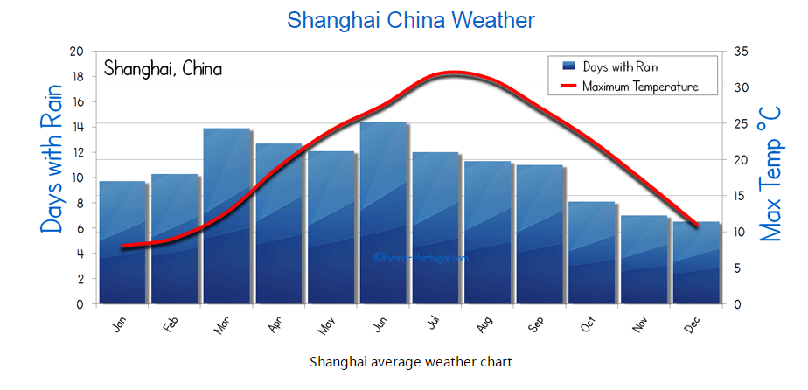

Currency
Chinese currency is called Renminbi (literally people's currency), often abbreviated as RMB. Issued by the People's Bank of China, it is the sole legal tender for both the Chinese nationals and foreign tourists. The unit for Renminbi is Yuan, Jiao and fen. The conversion among the three is: 1 Yuan = 10 Jiao =100 Fen.

Credit cards can be accepted at most hotels, tourist shops and some department stores.

Currency Conversion
One can change money upon arrival at the international airports of Shanghai. Also most hotels offer foreign exchange services and exchange cash and travelers cheques. The Bank of China exchanges money and travelers cheques. In China, wherever you exchange money the same day, the exchange rate is the same.

Power converter
Chinese standard Voltage is 220 volts. The America standard Voltage is 110volts. So a power converter will be needed when you want to charge your personal electronic devices.

Tourist Destination Recommendation
Tourist Destination in Jiading District

- Guyi Garden
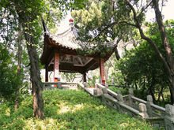
Guyi Garden is located in Nanxiang Town, Jiading District. Inside the garden, there are constructions such as Mid-Lake Pavilion, Nine Zigzag Bridge, Long Corridor and Plum Blossom Pavilion. The most famous historic relic in the Garden is One-Corner-Lacking Pavilion, which was built in 1931.
Add: 218 Huyi Road, Jiading District
Tel: 021-59124916
http://www.guyigarden.com/

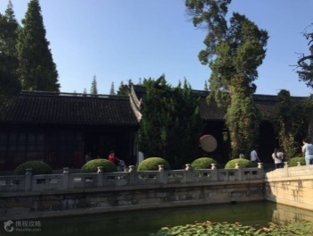
- Confucius Temple
Add: No. 183 Nandajie Road, Jiading District, Shanghai
Tel: 021-59530379/021-59928800
http://www.bytravel.cn/Landscape/11/jiadingkongmiao.html

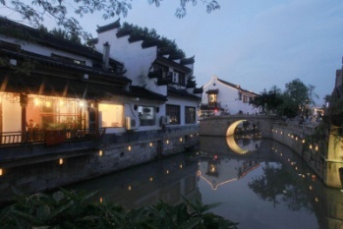
- Zhou Qiao
Add: No. 68 Shaxia Road, Jiading District, Shanghai
Tel: 021-59918114
http://jdz.jiading.gov.cn/lyjd/content_283379

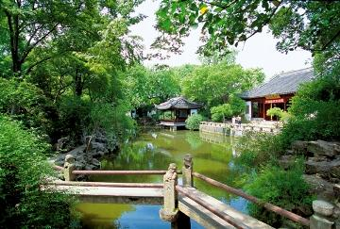
- Qiuxia Pu Garden
Add: No.314 Dongda jie Street, Jiading District, Shanghai
Tel: 021-59531949
http://jdz.jiading.gov.cn/lyjd/content_283382

Tourist Destination in Downtown Shanghai
- Oriental Pear TV Tower
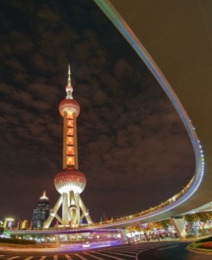
Oriental Pearl TV Tower is 468 meters high and is the hightest TV tower in Asia and the third highest in the world. It lies at the mouth of Lujiazui area beside Huangpu River and just opposite to the classical structures on the west Bund. The TV tower, together with Nanpu Bridge and Yangpu Bridge, look like two dragons playing with a ball - the view of which is a symbol of reform and the opening up of Shanghai to the world as the economic centre of the waking dragon that is China.
Add: 1 Century Avenue, Pudong New Area
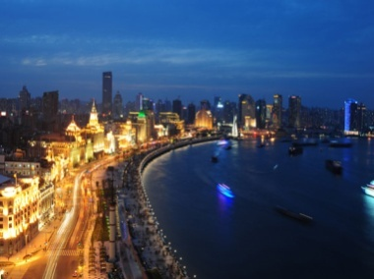
- The Bund
No.17 Fuzhou Rd. Huangpu District
021-63303333;021-63288299;021-63507059

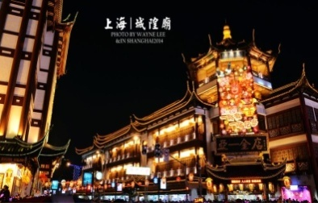

- The Chenghuangmiao Temple
NO. 249 Middle Fangbang Rd. Huangpu District
021-63842346

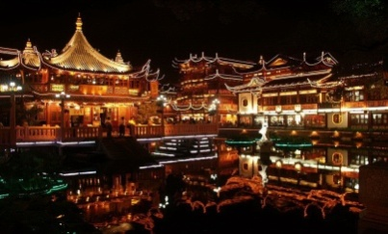
- Yu Garden
Wenchang Road, Yu Garden Huangpu District Shanghai
021-63260830


- Changfeng Sea World
No. 451 Dadu he Rd. Putuo District
021-60721488

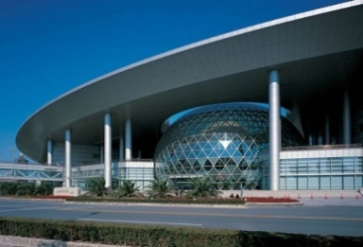
- Shanghai Science Museum
No.2000 Shiji Avenue Pudong District
021-68622000-6888

- Suzhou River
Suzhou River, divides Shanghai into two parts- the old and the new. The winding waterway is just like the road of history making its way down to the present as it makes its way down this artery to the Huangpu River-one views the great changes of the Grand Dragon that is Shanghai.
Add: From Jiangning Road Bridge to Changhua Road Bridge

- Huangpu River Cruise
Riding a cruise along the Huangpu River, you will take a glimpse of the history of Shanghai. On one side of the river, there is the Bund, a landmark of Shanghai. Lining the boulevard of the waterfront are grandiose solid buildings of Western style dating back to the early 19th century. You will also see the People's Heroes Monument and Huangpu Park, the city's first park. The evening cruise on Huangpu River presents a wonderful opportunity to appreciate the magnificence and grandeur of the Bund's night scenery in the glittery neon lights and the bright full moon.
Add: 1333 Wai Ma Road

- Zhujiajiao Ancient Watertown
The ancient water town Zhujiajiao with many bridges and lanes shows the abundant cultural atmosphere of this watertown. Known as "Shanghai’s Venice" - its waters are splendid and the town has cultivated many heroes during the past 1700 years. Zhujiajiao's many cultural events and activities are attracting the locals and visitors, adding a strong cultural atmosphere to the tranquility of these peaceful and ancient waterways and lanes.
Add: 23 Caoping Road, Zhujiajiao

Before you enter Shanghai, China, please DON'T FORGET
- You must get a visa before coming to China.
- Your passport must have a validity of 6 months at least.
- Cash. It's better for you to have some cash on hand. You can change RMB at exchange points in the airport. About 300 Yuan (US$50) is enough at first for a casual traveler.
- Anti-diarrhea tablets, antibiotics and any specialty medicines from home are useful. You should also take along some basic medicines, such as painkillers.
- Daily necessities. It's easy to buy things in China but when you first arrive, it may prove difficult. Bring shampoo, toothpaste, toothbrush for your first week and then you should be able to buy them at various local stores. They have imported products suitable for expats, such as hair dye and cosmetics.
- Clothes. It's not easy for tall or bigger boned Westerners to buy clothes in China, as the Chinese are typically far smaller. Shoes larger than size 11 are nearly impossible to obtain in China.
- Electricity adaptor. The most common plug types are the dual and three-pointed prongs, which are different from the West. China runs on 220 volts, which will burn 110-volt appliances.
Not necessary, but very handy
- Photocopies of important documents.
- Several passport photos.
- Your hotel's contact details in Chinese so you don't get lost

Frequently Asked Questions
What is the etiquette of having dinner in Shanghai?
Shanghai is a metropolis where eastern culture meets western culture. Usually those who pay the bill order dishes. Ladies get served first, and then the guests and hosts. Generally speaking, Chinese restaurants are relatively noisy, but VIP rooms are quiet and comfortable.
What are some of the wine customs of China?
China’s wines date back to over 5,000 years ago. And wine culture is a distinct form of Chinese culture whose traditional roots give it a very special place. Celebrations with wine are invariably found on many important occasions.
At the beginning of the event, the host will usually say a few words before giving the first toast. At that point, guests will rise from their seats and the host will finish all the wine in his cup. Afterwards, he will turn his cup over to show everyone that he has indeed finished the wine as a show of respect and sincerity. Guests usually finish their wine as well, and during the rest of the event the host will individually toast each table.
Guests should drink only what they can. Using other non-alcoholic drinks, tea, or water to receive toasts is also acceptable; the one giving the toast must be sympathetic to the other's circumstances. Guests can also toast their host, or each other.

Is tipping necessary when dining in Shanghai?
Consumer taxes are included in price tags on goods. Cafeterias and bars in all hotels and some restaurants and bars outside hotels may include a service charge of 10% to 15%. Tipping is not expected in most restaurants and hotels. But, tipping can be a way to show your satisfaction with the services.
Is it safe to drink water directly from the tap?
No. You are encouraged to drink bottled water. Normally, complimentary bottled water are provided for hotel guests.
Is it safe to walk in Shanghai?
Walking is great for sightseeing, but it's easy to get lost. Embrace the crowd. Don't expect smiles because we Chinese don't often look into others' eyes and smile to each other, even though most people are very friendly to foreigners.
You will find that Shanghai is a bustling city.
When you decide to go out on foot, remember to take paper and a pen along. Once you are confused by the labyrinth-like streets, which are famous for not following straight directions, you may write down your destination and ask passersby for help. Generally, youngsters in Shanghai can more or less speak some English.
Turning to the traffic policemen is another way when you need help. Be patient with them, for their English is not perfect, yet.
Be wary of aggressive drivers when crossing the streets. When the streets become extremely busy, to get rid of the traffic jam, drivers may even ignore the traffic lights. Even with the law on your side, you still need to be careful to avoid an accident. We do see a lot of foreigners cursing at rude cabbies and drivers who rush ahead of pedestrians to turn a corner.
Nowadays, some streets are equipped with countdown timers to tell you the time left for you to get across the street. Sometimes it is accompanied with a "beeper."
The downtown area is often crowded at weekends. Beware: thieves and fraudsters are always with the crowds. Keep an eye on your valuables and never bother to reply to any doubtful stranger.
Where to enjoy internet service?
Most hotels, public libraries, some restaurants and downtown cyber cafes provide free internet service. Tourists with laptops can enjoy wireless broadband Internet accessing service in these places.
Is it easy to find a public toilet in Shanghai?
All the public toilets in stores and restaurants are free of charge and open to every tourist. Public toilets in other places usually charge, but no more than 1 yuan. The specific charge standard is displayed at every public toilet.

