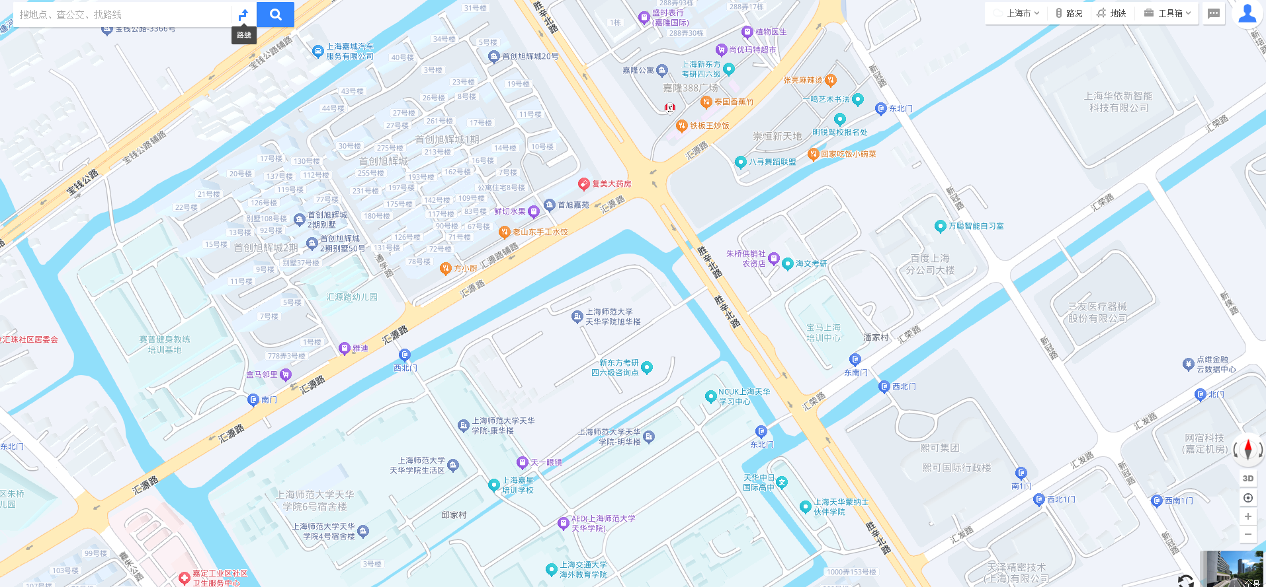
★ Minghua Building (International Office)
★ Xuhua Building (Classrooms)
★Hotel (Yitel Trend)
Luckin Coffee
KFC/Starbucks
Domino’s
Grocery
Grocery (L2)
McD’s
Fu-Mei Pharmacy
Huiyuan Rd.
Northwest Gate
Tianhua College

